**Title: To understand DDL and DML Command**

**Objective:** To understand the concept of designing issue related to the database with creating, populating the tables. To understand the concept of data constraints that is enforced on data being stored in the table. Focus on Primary Key and the Foreign Key.

**1.Create the tables for** Company database as per ER diagram of Exp 2.

TABLE 1: EMPLOYEE

[ Fname VARCHAR(15) NOT NULL,

Minit CHAR,

Lname VARCHAR(15) NOT NULL,

Ssn CHAR(9) NOT NULL,

Bdate DATE,

Address VARCHAR(30),

Sex CHAR,

Salary DECIMAL(10,2),

Super_ssn CHAR(9),

Dno INT NOT NULL,

PRIMARY KEY (Ssn),

FOREIGN KEY (Super_ssn) REFERENCES EMPLOYEE(Ssn),

FOREIGN KEY (Dno) REFERENCES DEPARTMENT(Dnumber)

]

TABLE 2: DEPARTMENT

[Dname VARCHAR(15) NOT NULL,

Dnumber INT NOT NULL,

Mgr_ssn CHAR(9) NOT NULL,

Mgr_start_date DATE,

PRIMARY KEY (Dnumber),

UNIQUE (Dname),

FOREIGN KEY (Mgr_ssn) REFERENCES EMPLOYEE(Ssn) );

]

TABLE 3: DEPT_LOCATIONS

( Dnumber INT NOT NULL,

Dlocation VARCHAR(15) NOT NULL,

PRIMARY KEY (Dnumber, Dlocation),

FOREIGN KEY (Dnumber) REFERENCES DEPARTMENT(Dnumber) );

TABLE 4: PROJECT

( Pname VARCHAR(15) NOT NULL,

Pnumber INT NOT NULL,

Plocation VARCHAR(15),

Dnum INT NOT NULL,

PRIMARY KEY (Pnumber),

UNIQUE (Pname),

FOREIGN KEY (Dnum) REFERENCES DEPARTMENT(Dnumber) );

TABLE 5: WORKS_ON

( Essn CHAR(9) NOT NULL,

Pno INT NOT NULL,

Hours DECIMAL(3,1) NOT NULL,

PRIMARY KEY (Essn, Pno),

FOREIGN KEY (Essn) REFERENCES EMPLOYEE(Ssn),

FOREIGN KEY (Pno) REFERENCES PROJECT(Pnumber) );

TABLE 6: DEPENDENT

( Essn CHAR(9) NOT NULL,

Dependent_name VARCHAR(15) NOT NULL,

Sex CHAR,

Bdate DATE,

Relationship VARCHAR(8),

PRIMARY KEY (Essn, Dependent_name),

FOREIGN KEY (Essn) REFERENCES EMPLOYEE(Ssn) );

**I/O:**

create database dbms;

use dbms;

Create TABLE employee (

Fname VARCHAR(15) NOT NULL,

Minit CHAR(1),

Lname VARCHAR(15) NOT NULL,

Ssn CHAR(9) NOT NULL,

Bdate DATE,

Address VARCHAR(30),

Sex CHAR(1),

Salary DECIMAL(10,2),

Super_ssn CHAR(9),

Dno INT,

PRIMARY KEY (Ssn),

FOREIGN KEY (Super_ssn) REFERENCES employee(Ssn)

);

CREATE TABLE department (

Dname VARCHAR(15) NOT NULL,

Dnumber INT NOT NULL,

Mgr_ssn CHAR(9) NOT NULL,

Mgr_start_date DATE,

PRIMARY KEY (Dnumber),

UNIQUE (Dname),

FOREIGN KEY (Mgr_ssn) REFERENCES employee(Ssn)

);

ALTER TABLE employee ADD FOREIGN KEY (Dno) REFERENCES DEPARTMENT(Dnumber);

CREATE TABLE dept_locations(

Dnumber INT NOT NULL,

Dlocation VARCHAR(15) NOT NULL,

PRIMARY KEY (Dnumber, Dlocation),

FOREIGN KEY (Dnumber) REFERENCES DEPARTMENT(Dnumber)

);

CREATE TABLE project(

Pname VARCHAR(15) NOT NULL,

Pnumber INT NOT NULL,

Plocation VARCHAR(15),

Dnum INT NOT NULL,

PRIMARY KEY (Pnumber),

UNIQUE (Pname),

FOREIGN KEY (Dnum) REFERENCES DEPARTMENT(Dnumber)

);

CREATE TABLE works_on(

Essn CHAR(9) NOT NULL,

Pno INT NOT NULL,

Hours DECIMAL(3,1),

PRIMARY KEY (Essn, Pno),

FOREIGN KEY (Essn) REFERENCES EMPLOYEE(Ssn),

FOREIGN KEY (Pno) REFERENCES PROJECT(Pnumber)

);

CREATE TABLE dependent(

Essn CHAR(9) NOT NULL,

Dependent_name VARCHAR(15) NOT NULL,

Sex CHAR,

Bdate DATE,

Relationship VARCHAR(8),

PRIMARY KEY (Essn, Dependent_name),

FOREIGN KEY (Essn) REFERENCES EMPLOYEE(Ssn)

);

1. **Insert the data given into their respective tables of Company database.**

**I/O-**

INSERT INTO employee (Fname, Minit, Lname, Ssn, Bdate, Address, Sex, Salary, Super_ssn) VALUES ('James', '', 'Borg', '888665555', '1937-11-10', '450 Stone, Houston TX', 'M', 55000.00, NULL),

('Franklin', '', 'Wong', '333445555', '1965-12-08', '638 Voss, Houston TX', 'M', 40000.00, '888665555'), ('Jennifer', '', 'Wallace', '987654321', '1941-06-20', '291 Berry, Bellaire TX', 'F', 43000.00, '888665555');

('Joyce', '', 'English', '453453453', '1972-07-31', '5631 Rice, Houston TX', 'F', 25000.00, '333445555'),

('Alicia', '', 'Zelaya', '999887777', '1968-01-19', '3321 Castle, Spring TX', 'F', 25000.00, '987654321'),

('Ramesh', '', 'Narayan', '666884444', '1962-09-15', '975 Fire Oak, Humble TX', 'M', 38000.00, '333445555'),

('Ahmad', '', 'Jabbar', '987987987', '1969-03-29', '980 Dallas, Houston TX', 'M', 25000.00, '987654321'),

('John', '', 'Smith', '123456789', '1965-01-09', '731 Fondren, Houston TX', 'M', 30000.00, '333445555');

Select * from employee;

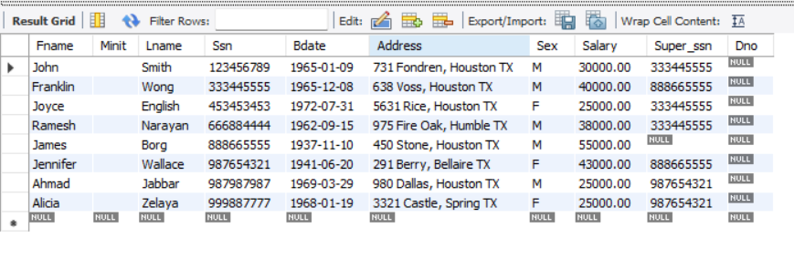

INSERT INTO DEPARTMENT VALUES

('Headquarters',1,'888665555','1981-06-19'),

('Research', 5, '333445555','1988-05-22'),

('Administration',4,'987654321','1995-01-01');

Select * from department;

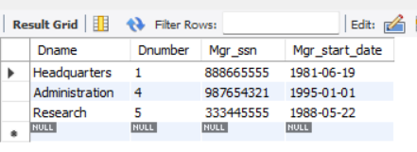

INSERT INTO project (Pname, Pnumber, Plocation, Dnum) VALUES

('ProductX', 1, 'Bellaire', 5),

('ProductY', 2, 'Sugarland', 5),

('ProductZ', 3, 'Houston', 5),

('Computerization', 10, 'Stafford', 4),

('Reorganization', 20, 'Houston', 1),

('Newbenefits', 30, 'Stafford', 4);

Select * from project

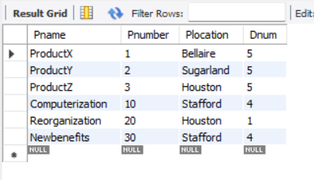

INSERT INTO works_on (Essn, Pno, Hours) VALUES

('123456789', 1, 32.5),

('123456789', 2, 7.5),

('666884444', 3, 40.0),

('453453453', 1, 20.0),

('453453453', 2, 20.0),

('333445555', 2, 10.0),

('333445555', 3, 10.0),

('333445555', 10, 10.0),

('333445555', 20, 10.0),

('999887777', 30, 30.0),

('999887777', 10, 10.0),

('987987987', 10, 35.0),

('987987987', 30, 5.0),

('987654321', 30, 20.0),

('987654321', 20, 15.0),

('888665555', 20, NULL);

Select * from works_on

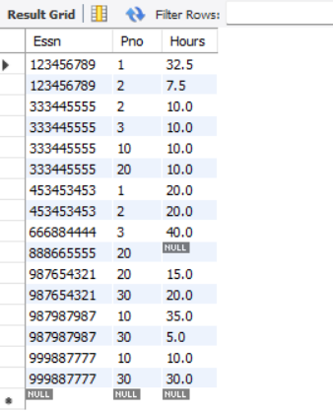

INSERT INTO dependent (Essn, Dependent_name, Sex, Bdate, Relationship) VALUES

('333445555','Alice','F','1986-04-04','Daughter'),

('333445555','Theodore','M','1983-10-25','Son'),

('333445555','Joy','F','1958-05-03','Spouse'),

('987654321','Abner','M','1942-02-28','Spouse'),

('123456789','Michael','M','1988-01-04','Son'),

('123456789','Alice','F','1988-12-30','Daughter'),

('123456789','Elizabeth','F','1967-05-05','Spouse');

Select * from dependent

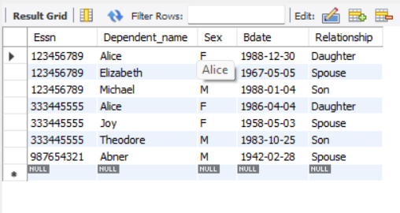

INSERT INTO dept_locations VALUES

(1,'Houston'),

(4,'Stafford'),

(5,'Bellaire'),

(5,'Houston'),

(5,'Sugarland');

Select * from dept_locations

